**PERSONAL LENDING SYSTEM**

**Description**

Personal Lending System (PLS) is a software solution, designed to help the Lender’s life much easier by keeping their Creditors’ records safe in one place. So Instead of manually writing down every creditor’s borrowed money or product on a paper, the Lender can just type it directly in the PLS. The system will then take care of keeping the data safe, and organize to make searching extra fast than keeping it in a physical record book.

**Features**

* Add new creditor’s information
* Edit creditor’s information
* Search creditors
* Delete creditors
* Record borrowed money or item
* Record payments made by the Creditor
* Search for the Creditor’s data
* Show the due Creditor of the day
* Login system

**Entity Relationship Diagram**

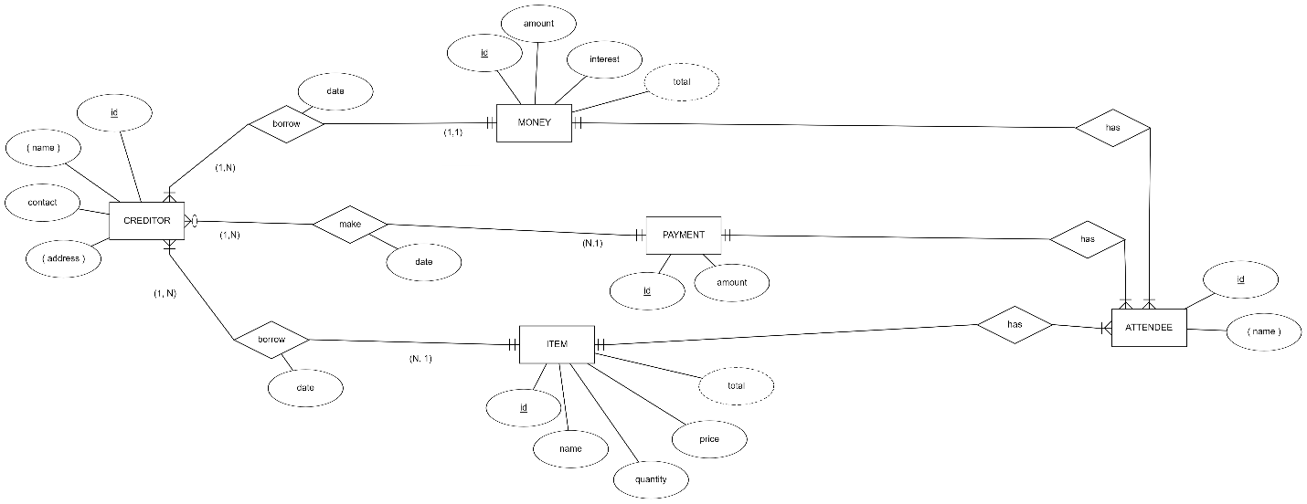

**Entity Relationship Mapping**

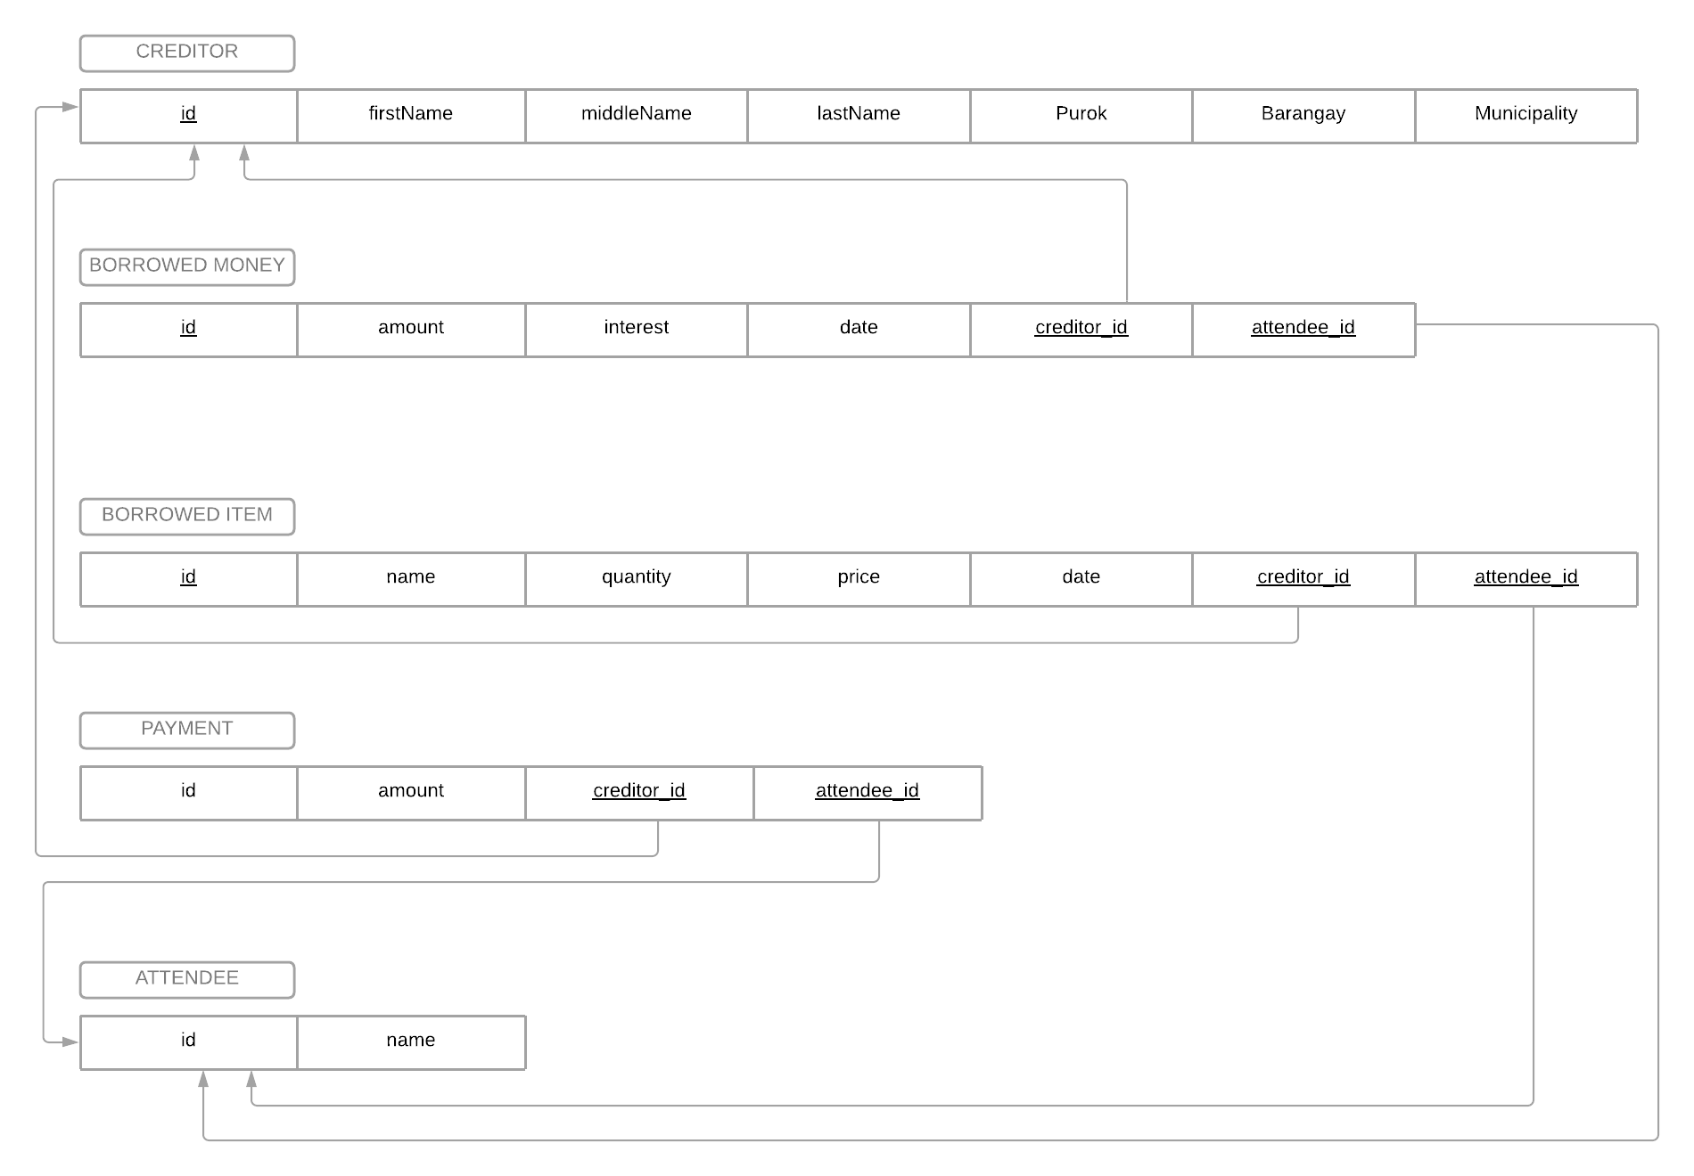

**Data Dictionary**

|  |  |  |  |  |  |  |
| --- | --- | --- | --- | --- | --- | --- |
| **TABLE** | **FIELD** | **DATA TYPE** | **DATA LENGTH** | **CONSTRAINTS** | **DESCRIPTION** | **EXAMPLE** |
| CREDITOR | id | int | N | Primary Key | Unique key of Creditor table | 1, 3, 4 |
| firstName | string | 50 | Not Null | First Name of the Creditor | Jane |
| middleName | string | 50 |  | Middle Name of the Creditor | Cardone |
| lastName | string | 50 | Not Null | Last Name of the Creditor | Doe |
| Purok | string | 50 | Not Null | Purok address of the Creditor | Mahayag |
| Barangay | string | 50 | Not Null | Barangay address of the Creditor | Unidad |
| Municipality | string | 50 | Not Null | Municipality address of the Creditor | Cagwait |
| BORROWED MONEY | id | int | N | Primary Key | Unique key of Borrowed_Money table | 1, 2, 3 |
| amount | int | N | Not Null | Amount of the borrowed money | 100, 500 |
| interest | int | 2 | Not Null | Interest of the borrowed money | 10, 20 |
| date | date |  | Not Null | Date when the Creditor borrowed Money | 12-21-2021 |
| creditor_id | int | N | Foreign Key | Primary key of the connected Creditor | 124 |
| attendee_id | int | N | Foreighn Key | Primary key of the connected Attendee | 125 |
| BORROWED  ITEM | id | int | N | Primary Key | Unique key of the Borrowed_Item table | 1,2,3 |
| name | string | 50 | Not Null | Name of the borrowed Item | Bugas, Tsinelas |
| quantity | int | N | Not Null | Quantity of the borrowed item | 3,5 |
| price | int | N | Not Null | Price of the borrowed item | 135, 520 |
| date | date |  | Not Null | Date when the item is borrowed | 12-04-2021 |
| creditor_id | int | N | Foreign Key | Primary key of the connected Creditor | 1,2,3 |
| attendee_id | int | N | Foreign Key | Primary Key of the connected Attendee | 1,3,4 |
| PAYMENT | id | int | N | Primary Key | Unique Key of the Payment table | 1,3,5 |
| amount | int | N | Not Null | amount of the payment | 150 |
| date | date |  | Not Null | Date the payment is made | 12-21-2021 |
| creditor_id | int | N | Foreign Key | Primary key of the connected Creditor | 1,3,5 |
| attendee_id | int | N | Foreign Key | Primary key of the connected Attendee | 14,5 |
| ATTENDEE | id | int | N | Primary Key | Unique Key of the Attendee table | 1,5 |
| name | string | 50 | Not Null | Name of the attendee | Joseph |

**SQL DDL**

DROP DATABASE IF EXISTS `lending_information`;

CREATE DATABASE `lending_information`;

USE `lending_information`;

CREATE TABLE creditors(

id INT NOT NULL AUTO_INCREMENT,

first_name VARCHAR(50) NOT NULL,

middle_name VARCHAR(50),

last_name VARCHAR(50) NOT NULL,

purok VARCHAR(50) NOT NULL,

barangay VARCHAR(50) NOT NULL,

municipality VARCHAR(50) NOT NULL,

PRIMARY KEY(id)

);

CREATE TABLE attendees (

id INT NOT NULL AUTO_INCREMENT,

full_name VARCHAR(50) NOT NULL,

PRIMARY KEY(id)

);

CREATE TABLE borrowed_money (

id INT NOT NULL AUTO_INCREMENT,

amount INT NOT NULL,

interest INT NOT NULL,

date DATE NOT NULL,

creditor_id INT NOT NULL,

attendee_id INT NOT NULL,

PRIMARY KEY(id),

FOREIGN KEY (creditor_id) REFERENCES creditors(id),

FOREIGN KEY (attendee_id) REFERENCES attendees(id)

);

CREATE TABLE borrowed_item(

id INT NOT NULL AUTO_INCREMENT,

name VARCHAR(50) NOT NULL,

quantity INT NOT NULL,

price INT NOT NULL,

date DATE NOT NULL,

creditor_id INT NOT NULL,

attendee_id INT NOT NULL,

PRIMARY KEY(id),

FOREIGN KEY (creditor_id) REFERENCES creditors(id),

FOREIGN KEY (attendee_id) REFERENCES attendees(id)

);

CREATE TABLE payment(

id INT NOT NULL AUTO_INCREMENT,

amount INT NOT NULL,

date DATE NOT NULL,

creditor_id INT NOT NULL,

attendee_id INT NOT NULL,

PRIMARY KEY(id),

FOREIGN KEY (creditor_id) REFERENCES creditors(id),

FOREIGN KEY (attendee_id) REFERENCES attendees(id)

);

CREATE TABLE users(

id INT NOT NULL AUTO_INCREMENT,

username VARCHAR(8) NOT NULL,

password VARCHAR(20) NOT NULL,

PRIMARY KEY(id)

);